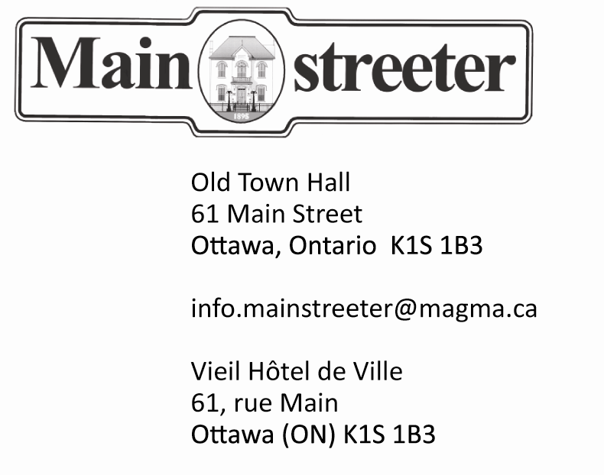

Advertising Rates, 2018
Size Width X Price/Issue Discounted Price* Height B&W / Colour B&W / Colour _____________________________________________________
Full Page 10 x 13 $350 / $390 $270/ $300
Full Back Page 10 X 13 $480 $370
Half Page 10 X 6.5 $190 / $210 $150 / $160
Or 5 X 13
Quarter Page 5 X 6.5 $100/ $110 $80/ $90
Banner, Top 10 X 2.5 $90/ $100 $70/ $75
Or Bottom
Eighth Page 2.5 X 6.5 $55/ $60 $45 / $50
Or 5 X 3.5
Business Card 3.5 X 2 $35 $40 $30 / $35
2 X 3.5
We accept ads in either jpg, pdf, tiff or eps formats, with a minimum resolution of 300dpi
Discounted price available with the purchase of six consecutive issues.
Advertising Manager, Ron Rose, 613-680-9000 advertising@mainstreeter.ca

