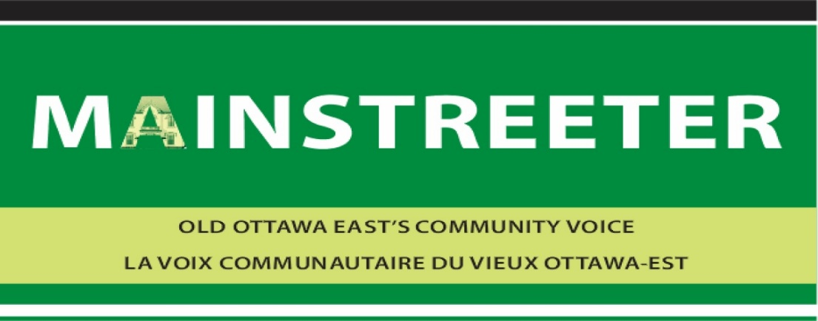

WHO WE ARE
The Mainstreeter is a non-profit community newspaper supported by its advertisers. We have been the voice of Old Ottawa East for over 35 years.
We publish six issues each year and distribute the paper in print, pdf via email and by posting to our media feeds at:
http://www.mainstreeter.ca/
https://www.facebook.com/Mainstreeter/
https://twitter.com/MainstreeterOtt

WHO WE REACH
Old Ottawa East residents are affluent and highly educated. Average household income is $104,609 while 77% hold a bachelor degree or higher, compared to 45% in Ottawa as a whole. Households are split between owners and renters. Approximately 8,750 people live in Old Ottawa East, with the population having grown by almost 25% since 2016.
Three key factors fuel this growth:
- The Greystone Village housing development that will see close to 1000 new homes, condos and apartments upon completion
- The transformation of Main Street into a compete street which gives as much preference to pedestrians and cyclists as it does to cars
- The recently built Flora Footbridge over the Rideau Canal connecting Old Ottawa East to the Glebe
The community is sandwiched between the Rideau Canal and the Rideau River which form it western and eastern boundaries. The Queensway and Nicolas Street form the norther border with Avenue Road in the south.

CIRCULATION AND DISTRIBUTION
4,000 copies per issue are hand-delivered to every family dwelling and business in the community. Copies are also available to residents of condominiums and apartments through four conveniently located newspaper boxes. A fifth newspaper box is at the base of the Flora Footbridge.

2022 ADVERTISING RATES
Size | Width x Height | B&W | Colour
Full Back Page | 10 x 13 | N/A | 528
Full Page | 10 x 13 | 385 | 429
Half Page | 10 x 6.5 OR 5 x 13 | 209 | 231
Quarter Page | 5 x 6.5 | 110 | 121
Banner (top or bottom) | 10 x 2.5 | 99 | 110
Eighth Page | 2.5 x 6.5 OR 5 x 3.5 | 61 | 66
Business Card | 3.5 x 2 OR 2 x 3.5 | 39 | 44

We offer a 10 percent discount based on 6 consecutive issues.
We accept ads in either jpg, pdf, tiff or eps formats. CMYK, with a minimum resolution of 300 dpi.

2022 CONTENT DEADLINES AND PRODUCTION SCHEDULE
Articles/advertisement Booking Date | Articles/advertisement Submission Date | Publishing date
#1 January 14, 2022 | January 28, 2022 | February 11, 2022
#2 March 11, 2022 | March 25, 2022 | April 14, 2022
#3 May 13, 2022 | May 27, 2022 | June 10, 2022
#4 July 15, 2022 | July 29, 2022 | August 12, 2022
#5 September 9, 2022 | September 23, 2022 | October 7, 2022
#6 November 14, 2022 | November 28, 2022 | December 9, 2022
CONTACT INFORMATION

Lorne Abugov Cynthia Dwyer
Editor Advertising Manager
editor@mainstreeter.ca advertising@mainstreeter.ca
613-878-1532 613-878-8364

